Canadian History 11: Fathers of Confederation Biography and Diary Entry

Canadian History 11
Mr. Wilson
mrwilson@nspes.ca

Driving Question: Who were the Fathers of Confederation and what was their role in the creation of Canada? How would these men react to events that are important to Canada today?

Outcomes Covered:
- G3 analyze how emerging political and economic structures led to confederation
- G4 evaluate the evolution of federalism in Canada from Confederation to Patriation

Expected Length of Lesson:
- Four 50-minute classes.

Resources Needed for Lesson:
- Teacher computer with access to the Internet.
- LCD projector to connect to teacher computer.
- Computer lab access with computers for each student (room 205)
- Assignment handout.
- Watch the following documentary on the Fathers of Confederation
https://www.youtube.com/watch?v=iFjkaY4JMh4
- Access to programs for making posters (Prezzi, Powerpoint, Piccollage, Publisher, Word, etc…
- Colouring pencils or markers (if students wish to draw theirs)
- 8x11 paper (for good copy if students draw theirs posters)

Purpose of the Lesson:
- Students will understand the role the Fathers of Confederation had on the shaping of the lands of Canada.
- Students will have a better understanding of the key individuals involved in Canadian Confederation
- Students will create an illustration and write-up for the group they pick.
- Students will learn how to research the person and diary topic they pick.
- Students will learn to validate the facts they find in their research.
- Students will learn how to write a proper diary entry.

Rubric
Category | 4 | 3 | 2 | 1
Title | Title is clear, neat, and well designed. | Title is clear, neat, but lacks creativity | Title is clear but somewhat messy and lacks creativity | Title is not clear or is not present
Poster Elements | All the elements are included and the poster demonstrates exceptional creativity | All the elements are included but creativity is lacking. | Some elements are present but there are some also missing. | The majority of required elements are missing
Drawing | The drawing shows great effort and research on what the person looked like. | The drawing shows effort but does not represent the person well. | The drawing seems rushed and is messy. Does not represent the person. | No drawing is included on the poster.
Diary Write-ups | All the diary entries are present and meet the appropriate length. | All the diary entries are present but are not the appropriate length. | Diary entries are missing and short in length. | Diary entries are not done or are not acceptably done.
Historical Accuracy | The research of the person and topic is clear and there are no historical inaccuracies. | The research of the person and topic is somewhat clear and there are no historical inaccuracies. | The research of the person and topic is not clear and there are historical inaccuracies. | There is no evidence that research was conducted during he project. There are historical inaccuracies throughout.

Lesson Process
- First class: 1) The teacher will hand out the assignment sheet and go over the expectations for the assignment. 2) The students will review the sheets and ask any questions of the teacher before starting. 3) Students will watch the following video on Confederation to get a better understanding of the event. https://www.youtube.com/watch?v=iFjkaY4JMh4
4) Students will view the list of the Fathers of Confederation and begin initial research (can be done together with other classmates) to decide on which Father of Confederation they would like to do the research on.5) Students will pick the person they wish to do their project on.
6) The teacher will wrap up the class by explaining that tomorrow will be used conduct their research and start creating their biography poster.

- Second class: 1) the teacher will review what was accomplished yesterday, and reinforce the importance of focusing on the research for their Father of Confederation and create their biography poster. 2) Students will use their devices of lab computers to research their Father of Confederation and gather information.3) Students will create their poster, adding in a picture, biography questions, and interesting facts.4) The poster must have a title, colour, and their own illistrations.5) The teacher will close the lesson by explaining the plan for tomorrow which will include finalizing their poster and starting their diary write-up.

- Third class: 1) the teacher will start the class by enforcing the need to focus on the finalizing of the posters from yesterday and the need begin the research on the modern topic provided for them. 2) Allow students time to work on their posters. Circulate around the room to help individuals as needed and make sure all elements are being added. 3) Students will pick from the three modern topics:
1) Quebec plans to separate from Canada and the separation movement
2) The Trans-Canada natural gas pipeline
3) Canada’s war against ISIS and ISIL
4) Students will conduct research with a partner to get a better understanding of the three topics. 5) Individually, students will pick the topic they wish to write their diary entries from. 6) The teacher will wrap up the class by reminding students that tomorrow will be focused on completing their three diary entries.

- Fourth class: 1) The teacher will start the class by ensuring the class is focused on completing their diary entries today on the three topics reviewed yesterday. 2) Students will write their diary entries staying in their character role and imagining how their Father of Confederation would react to the modern topic they have chosen. 3) The teacher will wrap up the class by reminding the class that the finalized project is due tomorrow at the beginning of class. This must include the biography poster and the diary entries
Fathers of Confederations Profile and Diary Assignment

Canadian History 11
Mr. Wilson
mrwilson@nspes.ca

For this assignment you are to pick one Canadian father of Confederation from our history and create a biographic poster that outlines the person you choose and what makes them famous/a true Canadian. Your final poster can be done in a program of your choice (Publisher, Word, Prezzi, Weebly webpage, Piccollage, etc….) Your biography is going to give the basic background of the person and their role in the creation of Confederation in Canada. Once that is done, you will have to write a series of three diary entries (minimum of three paragraphs for each entry) on a modern topic I will give you to research and imagine how that Father of Confederation would react today to modern issues here in Canada.

Your poster must include these elements:

- A title at the top of the page (use the person’s name).
- A DRAWING of that person (try your best….I will mark on effort not artistic ability.
- Your poster must include colour.
- You must give include the following info:
- Where they were born.
- What year they were born.
- What was their role in Canadian Confederation (for or against? What meetings did they attend? What were they best known for?
- Why you picked this person (aim for 2 paragraph minimum in your own words).
- Any other interesting facts you find.
- Finish your good copy on the white paper I will provide.
- Place your name and date handed in on the back of the poster.

Some possible Fathers of Confederation: (there are more you can Google)

- George Brown | - Alexander Campbell
- Frederick Carter | - George Etienne Cartier
- James Cockburn | - Alexander Galt
- Sir Hamilton Gray | - William Alexander Henry
- John A. MacDonald | - Charles Tupper
- Samuel Tilley | - Robert Duncan Wilmont
- Edward Whalen | - William Steeves
- Ambrose Shea | - William Henry Pope
- Edward Palmer | - Oliver Mowat
- Thomas D’Arcy McGee | - Thomas Heath Haviland

Above is an example of how your poster layout might look. You may choose to change the layout but remember that your poster must have the required elements listed on the first page.
Personal Write-up
Biographic Information

Interesting Facts etc……
Picture

Title

Content checklist:
☐ Title
☐ Drawing of person.
☐ Colour
☐ Biographic information
☐ Interesting facts
☐ Two paragraphs of personal response
☐ Name and date on back of sheet

Diary Entries:

Once the biography poster is complete, you will now move onto the diary response portion of the assignment. Know that you know a little about your Father of Confederation, you are going to compile a minimum of three diary entries (minimum of three paragraphs) in the role of your selected politician in response to a modern issue in Canada. I will give you three topics to pick from and you will write imagining how that person would respond. These diary entries can be typed (use creative font) or ideally handwritten to make the diaries look older. Below are the topics you can pick from. Pick only one. You will have to research the topic (can be done in groups) to bet a better understanding of which one you want to do.

Topics: 1) Quebec plans to separate from Canada and the separation movement
2) The Trans-Canada natural gas pipeline
3) Canada’s war against ISIS and ISIL

Diary Checklist:

☐ Three entries minimum
☐ Spelling and grammar is accurate
☐ Entries are in character and written from the perspective of your Father of Confederation and include historically accurate dates.
☐ Topic is well researched
☐ Entries must contain facts about the topic
☐ Entries must be attached to the biography poster

Example Diary Entry:

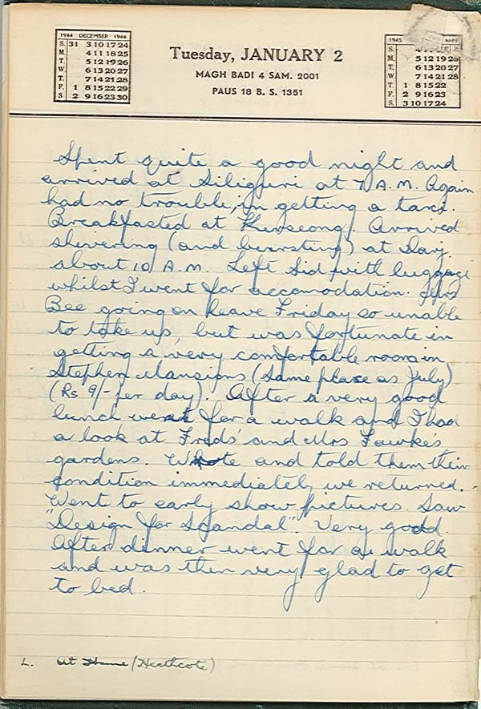

Rubric:

Category | 4 | 3 | 2 | 1
Title | Title is clear, neat, and well designed. | Title is clear, neat, but lacks creativity | Title is clear but somewhat messy and lacks creativity | Title is not clear or is not present
Poster Elements | All the elements are included and the poster demonstrates exceptional creativity | All the elements are included but creativity is lacking. | Some elements are present but there are some also missing. | The majority of required elements are missing
Drawing | The drawing shows great effort and research on what the person looked like. | The drawing shows effort but does not represent the person well. | The drawing seems rushed and is messy. Does not represent the person. | No drawing is included on the poster.
Diary Write-ups | All the diary entries are present and meet the appropriate length. | All the diary entries are present but are not the appropriate length. | Diary entries are missing and short in length. | Diary entries are not done or are not acceptably done.
Historical Accuracy | The research of the person and topic is clear and there are no historical inaccuracies. | The research of the person and topic is somewhat clear and there are no historical inaccuracies. | The research of the person and topic is not clear and there are historical inaccuracies. | There is no evidence that research was conducted during he project. There are historical inaccuracies throughout.

