Canadian History 11: Digital Storytelling End of Year Project

Canadian History 11
Mr. Wilson
mrwilson@nspes.ca

Driving Question: What have you learned throughout the course this year? What topic would you like to research further?

Outcomes Covered:
- Varies by student as this is a end of course research project.

Expected Length of Lesson:
- Five 50-minute classes.

Resources Needed for Lesson:
- Teacher computer with access to the Internet.
- LCD projector to connect to teacher computer.
- Computer lab access with computers for each student (room 205)
- Assignment handout.
- Access to film recording software like iMovie or QuickTime
- Students should have their notes to review material covered over the entire course.
- Scrap paper for rough copy storyboards
- Access to free to use music like on www.bensound.com/
- Video explaining the fundamentals of digital storytelling
https://www.youtube.com/watch?v=a1f-_FXgJZM

Purpose of the Lesson:
- Students will show their understanding of topics we covered this school year.
- Students will learn to work in a group with a fellow classmate.
- Students will create a digital story using a program of their choice
- Students will learn how to research the topic they make the digital story on.
- Students will learn to validate the facts they find in their research.
- Students will learn how to edit their digital stories.

Lesson Process
- First class: 1) The teacher will hand out the assignment sheet and go over the expectations for the assignment. 2) The students will review the sheets and ask any questions of the teacher before starting. 3) Students will pair up with a classmate who they will do the project with.4) Students will watch the following video on Confederation to get a better understanding of the event. https://www.youtube.com/watch?v=iFjkaY4JMh4
5) Students will examine the list of main topics on the assignment sheet and narrow down the topic they wish to work on. 5) Students will decide on the media format they wish to do their projects on. Most in my room are familiar with iMovie but can use any other they wish.
6) The teacher will wrap up the class by explaining that tomorrow will be used to decide on the topic and conduct their research on the topic they have picked.

- Second class: 1) the teacher will review what was accomplished yesterday, and reinforce the importance of deciding on their topic and the beginning of their research on the topic. 2) In their groups, the students will pick their topic.3) Groups will start their preliminary research and rough brainstorming of ideas..4) Students will back their information up with images and music. Free licensed music can be found on www.bensound.com/ .5) The teacher will close the lesson by explaining the plan for tomorrow which will include creating their storyboard and the placing of the research into their videos.

- Third class: 1) the teacher will start the class by enforcing the need to focus on the storyboards that will layout the flow of their digital stories. 2) Allow students time to work on their storyboards. Circulate around the room to help individuals as needed and make sure all elements are being added. 3) Groups will start placing all their images, information, and music into their multimedia program.4) The teacher will wrap up the class by reminding students that tomorrow will be focused on completing their information into their final digital story.

- Fourth class: 1) the teacher will start the class by ensuring the class is focused on completing their digital stories. 2 Groups will work on the remainder of this class to finalize their digital stories.. 3) The teacher will wrap up the class by reminding the class that the finalized project is due tomorrow at the beginning of class. They will present their digital stories and will submit them at the end of class with their digital storyboard.

- Fifth class: 1) this class will be used entirely to present the digital stories. Students will present their videos and field any questions their classmates may ask. 2) The teacher will wrap up the project by giving feedback and discussing any observations on how the project went.

Rubric
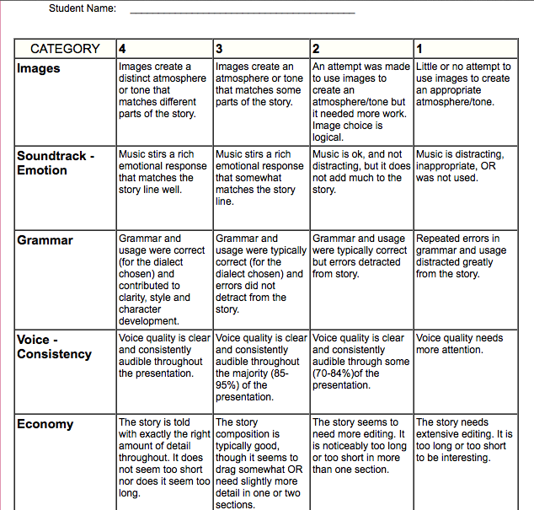

Digital Storytelling in Canadian History 11

Canadian History 11
Mr. Wilson
mrwilson@nspes.ca

For this assignment, you are going to be creating a digital story for any of the historical events we have covered to this point in the course. This assignment will be done in groups of two (you can choose your partner). Your video must follow the following guidelines:

- You must have a storyboard that shows the planning included in your story. This will be handed in on the due date.
- The video must be 90 seconds in length (minimum)
- The story must cover one of the historical events we have covered in this class so far this year.
- The story must have images, narration, music, and text.
- All sources of video, images, music, and information must be cited at the end of the video.
- The music must represent the topic and tone of the information you are presenting. Example: if the information is dark or sad, it should have music that fits. Not happy music.

The video can be created on any program you wish (IMovie, QuickTime, etc.…). We have used IMovie in class before so most of you are familiar with this program. IMovie is also on our class I-Pads if you wish to use it.

Potential topics :(all have been covered in class). Everyone must clear their topic with me before they start. These topics below are just recommendations.

- The Norse adventures to the New World (discovery of Newfoundland)
- First contact between Europeans and First Nations
- Champlain’s expedition along the St. Lawrence River
- The deportation of the Acadians in 1755
- The War of 1812
- The Northwest Rebellion
- The Upper Canadian Rebellion
- The Lower Canadian Rebellion
- The planning and establishment of Confederation
- Protecting against American Manifest Destiny
- The legacy of Residential Schools
- The Boer War
- World War One
- The Roaring 20’s
- The Great Depression
- World War Two
- The internment of Japanese Canadians
- War on the home front
- The Holocaust
- The rise and fall of Africville
- Newfoundland Resettlement
- And many more…clear with Mr. Wilson first.

When creating a digital story, you must make sure that it is well planned out before recording. You must take the time to decide your topic, research the topic, and so on. Here is a step-by-step process to help keep you on track.
Step 1: Pick your partner. When working with a partner, pick someone who you know you will work well with and will contribute to the assignment. You will need to collaborate with this person throughout the assignment so put some thought into which person you pick.
Step 2: Watch the following video on the principals of digital storytelling
https://www.youtube.com/watch?v=a1f-_FXgJZM
Step 3: Pick the topic you wish to create the digital story on (see list above). You must tell Mr. Wilson your decision to make sure there are duplicates.
Step 4: Decide the recording and multimedia platform you want to use. This is up to you. It can be programs such as IMovie, Windows Movie Maker, QuickTime, Bolide Movie Maker, etc… Pick a program you are comfortable with. If using my class IPads, they all have the latest IMovie installed.
Step 5: Begin defining and researching the topic. Most topics are broad so you will need to pick your focus. For example, if you are doing your digital story on World War Two, will you focus on a specific battle? Particular political figures? Specific regiments or battalions? The options are endless. Consult with your partner and divide up the roles fairly.
Step 6: Find music and images to accompany your digital story. All images and music must be cited at the end of the video in your credits. Music must be free to license or royalty free and cannot be copyrighted. A good site I often use is: www.bensound.com/. Remember that the music you pick should fit the topic and images in your video. Dark or sad topics should have music that matches. Happy events should have music that reflects that. See me if you need help.
Step 7: Create a storyboard. This can be placed on white printer paper (on my desk) and will show the order and plan for your video. This should indicate the design, text locations, picture locations, and so on. Use this storyboard to help you organize your final product. This should have as much detail as possible.
Step 8: Start placing your images, music, and information into the program you chose. Start editing and trying new places for the material. This is a time consuming and tedious process. Have patience.
Step 9: Finalize your video and get prepared to show it to the class. Your video should not require you to speak outside the video and should tell the whole story in itself. The viewer should be able to watch your video and understand the whole story/event.
Step 10: Once all videos are shown, we will meet back as a class to discuss the assignment and recommendations for additions or changes for next year.
How you will be marked:

