Canadian History 11: World War Two Twitter Project

Canadian History 11
Mr. Wilson
mrwilson@nspes.ca

Driving Question: What would dialogue been like leading up to the outbreak of World War Two if leaders had access to social media like Twitter?

Outcomes Covered:
- SCO:2. Identify those individuals, events, and/or symbols that they believe have on the shaping of Canada and the world.
- GL4 Analyze the role played by WW2 in shaping Canada's identity

Expected Length of Lesson:
- Three 50-minute classes.

Resources Needed for Lesson:
- Teacher computer with access to the Internet.
- LCD projector to connect to teacher computer.
- Computer lab access with computers for each student (room 205)
- Assignment handout.
- Teacher made video describing how to do the twitter project:
http://my.brainshark.com/Twitter-Canadian-Project-395446952
- Teacher made video to help students have a clearer understanding of the outbreak of World War Two:
http://my.brainshark.com/World-War-Two-Outbreak-69919023
- Access to Twitter (make sure your school is not blocking it).
- TeamShake app (optional) to make randomized teams of 5.
https://itunes.apple.com/ca/app/team-shake/id390812953?mt=8

Purpose of the Lesson:
- Students will understand the events that led to the outbreak of World War Two.
- Students will learn the impact social media would have played in historical events of the past.
- Students will learn to conduct historical research.
- Students will learn to evaluate and validate information they have researched.
- Students will learn to collaborate with each other in groups and work as a team to create tweets.
- Students will learn to assume the role given and use their imagination to place themselves in the time period.

Rubric
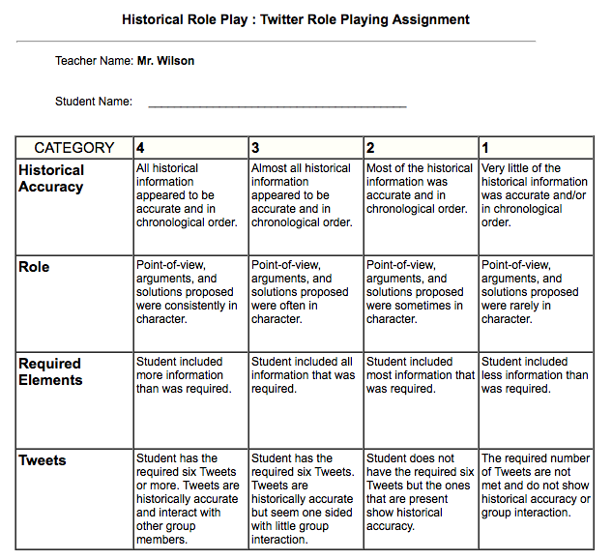

Lesson Process

- First class: 1) The teacher will hand out the assignment sheet and go over the expectations for the assignment. 2) The students will review the sheets and ask any questions of the teacher before starting. 3) Students watch the teacher made video explaining how the project will take form:
http://my.brainshark.com/Twitter-Canadian-Project-395446952
4) Students will watch the teacher made video reminding them how World War Two broke out. This will be review as we have already gone over this information in class.
http://my.brainshark.com/World-War-Two-Outbreak-69919023
5) The teacher will randomly divide the class into groups of five. This can be done using the TeamShake app if you wish.
https://itunes.apple.com/ca/app/team-shake/id390812953?mt=8
6) The teacher will wrap up the class by explaining that tomorrow will be used to meet in their assigned groups as conduct the research for the role their assigned historical figure would have played in the time period.

- Second class: 1) the teacher will review what was accomplished yesterday, and reinforce the importance of collaborating as a group. 2) Instruct the students to assign roles to each person in the group to conduct the research. 3) One member of the group will create a Twitter account for the person they are assigned.. 4) The group will create a biography on their person 5) The group will add a picture for their person 6) The teacher will close the lesson by explaining the plan for tomorrow. Tomorrow will be the actual writing of the Twitter conversation as a class.

- Third class: 1) The teacher will review the expectations of the Twitter conversations. 2) The groups will meet before the discussion starts to brainstorm ideas and determine who will type as each group only needs one Tweet. 3) Each group is to do a minimum of six Tweets. These tweets must be historically accurate to the time period topic, and must interact with previous Tweets from other group personas. 4) The class will end with the teacher wrapping up the lesson. We will have a class discussion on what went well and what could be improved. Finish by reviewing the entire conversation as a class.

The Event:

The groups will be immersed into the time period leading up to World War Two. They will research and Tweet from the individuals who played a role in the events leading to the war, and the outbreak of the war itself.

The Groups:

- British Prime Minister Neville Chamberlain (The British Prime Minister at the outbreak of World War Two)
- Adolf Hitler (The Chancellor of Germany)
- Edward Rydz-Śmigły (Polish commander in chief of all defending Polish forces in 1939).
- Joseph Stalin (Premier of the Soviet Union….locked in a non-aggression pact with Germany in 1939. Helped invade and won the eastern portion of Poland following the invasion.).
- William Lyon Mackenzie King (Canada’s Prime Minister during World War Two).

World War Two: Twitter Project
Canadian History 11
Mr. Wilson
mrwilson@nspes.ca

Ever wonder how certain historical figures would have acted if they had social media like we do today? What if Christopher Columbus had Facebook or Joseph Stalin had Twitter? Would anyone follow Vladimir Lenin on Twitter or send Snaps to Che Guevara on Snapchat? Hard to imagine isn’t it?
For this assignment, you will work in small groups, which will be assigned a historical event we cover in this course, and the key figures attached to that event. Each member of the group will take on the persona of one historical figure and interact with the others in the group using Twitter. Each group will be given a time period to immerse yourselves in where you will become the character you are given. You will then Tweet with other in the group while staying in character.
There will be five groups total. These will be picked at random using the TeamShake app.
Once the groups and character roles are decided, you will create temporary Twitter accounts (I recommend using your school emails) and follow my school Twitter account at: MrWIlsonNGRHS. Only one account is needed per group.
I will have a closed account, which will be private. You will create your temporary account using the character you are assigned. Then you must create a bio (a blurb about the person), a profile photo of the person, and other interests you choose to add (research the person…make it personal to them). Examples: John F. Kennedy loved water sports. You could add in his interests “I like waterskiing and boating with my family in Hyannis Port, Massachusetts”. Joseph Stalin liked to read (some say over 500 pages a day) and enjoyed hunting on the Siberian Plains. He also loved cars. You could add: “I love sitting down with a good book when not hunting bear and wolf. On weekends I enjoy long drives in the countryside in my 1936 Packard.”
Once your profile is set up, you will need to research the event and the role your assigned person played in that event. Try to learn about their personalities, their fears, and likely action.
On the final day, the Twitter conversation will occur. Each group will be required to Tweet a minimum of six times. These tweets must be in character and provide interaction between the other members. For example: Fidel Castro during the Cuban Missile Crisis might tweet JFK “@JFK: Why must you insist on invading my island? My business with the USSR is private” to which JFK could respond “@FidelC: The breaking of the Monroe Doctrine makes your business with the USSR my business” and so on. These are just examples.

Here are the events and characters:

Historical Event: September 1, 1939. Germany has just invaded Poland in a surprising blitzkrieg. Adolf Hitler and his German forces quickly move in to take the country over (which took only one month). Joseph Stalin’s Russia was in a non-aggression pact and helped with the invasion from the east. Canada and Britain pondered their duty and if they should enter the war.

- British Prime Minister Neville Chamberlain (The British Prime Minister at the outbreak of World War Two)
- Adolf Hitler (The Chancellor of Germany)
- Edward Rydz-Śmigły (Polish commander in chief of all defending Polish forces in 1939).
- Joseph Stalin (Premier of the Soviet Union….locked in a non-aggression pact with Germany in 1939. Helped invade and won the eastern portion of Poland following the invasion.).
- William Lyon Mackenzie King (Canada’s Prime Minister during World War Two).

The Process:

- Watch the screencast that will outline the project:
http://my.brainshark.com/Twitter-Canadian-Project-395446952
- Watch the screencast that will refresh you on the information that led to the outbreak to World War Two:
http://my.brainshark.com/World-War-Two-Outbreak-69919023
- Get your assigned group from Mr. Wilson
- Decide in your group who will play what character
- Create a temporary Twitter account for your character. Make it a closed, private account.
- Research your character and create a profile picture, general profile (using historically accurate facts), and any other interesting facts.
- Follow Mr. Wilson at: MrWilsonNGRHS
- Begin tweeting from your characters persona about the event you have been assigned. Think how they would talk, react, and interact.
- Tweet a minimum of six times. Each time add my account in the tweet so I can see them easily @MrWilsonNGRHS.
- We will finish the assignment by looking at each groups interactions and talk about their accuracy, validity, and other comments.

Rubric

