Canadian History 11: World War One Letter Writing Project

Canadian History 11
Mr. Wilson
mrwilson@nspes.ca

Driving Question: How did people living through World War One communicate with each other through letters? What were they communicating to each other? Who were they writing to?

Outcomes Covered:
- SCO:2.Identify those individuals, events, and/or symbols that they believe have
- GL4 Analyze the role played by WWI in shaping Canada's identity

Expected Length of Lesson:
- Three 50-minute classes.

Resources Needed for Lesson:
- Teacher computer with access to the Internet.
- LCD projector to connect to teacher computer.
- Computer lab access with computers for each student (room 205)
- Assignment handout.
- Teacher made video describing how to write a friendly letter:
http://my.brainshark.com/Friendly-Letter-Writing-Format-364139449
- War letter and diary database
https://www.collectionscanada.gc.ca/archivianet/020152_e.html
- Library and Archives of Canada website. This will help access example letters.
- http://www.bac-lac.gc.ca/eng/Pages/home.aspx

Purpose of the Lesson:
- Students will understand the people that lived through World War One and experienced it firsthand.
- Students will learn how to write a friendly letter.
- Students will learn to research primary document letters from the First World War.
- Students will learn about the events in the war that they include in their letter.
- Students will learn principles of audience, tone, and structure in a letter.
- Students will learn to use their imaginations to assume the roles of the persona they are writing as.

Rubric
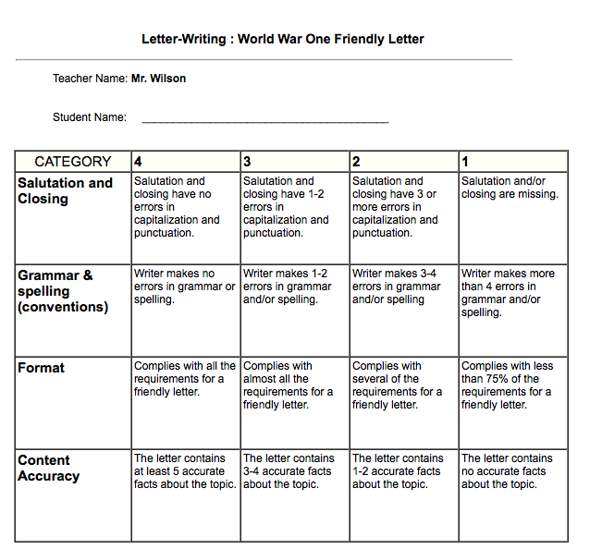

Lesson Process

- First class: 1) The teacher will hand out the assignment sheet and go over the expectations for the assignment. 2) The students will review the sheets and ask any questions of the teacher before starting. 3) Students watch the teacher made video explaining how to write a friendly letter and the fundamentals of letter writing.
http://my.brainshark.com/Friendly-Letter-Writing-Format-364139449
4) Students will examine the different databases and conduct research on friendly letters written at war. These databases will give plenty of ideas on how letters were written. These databases will give students a starting point on how these letters looked.
-https://www.collectionscanada.gc.ca/archivianet/020152_e.html
-http://www.bac-lac.gc.ca/eng/Pages/home.aspx
5) The teacher will wrap up the class by explaining that tomorrow will be used to create their bio and physically write the letters in the persona they chose.

- Second class: 1) the teacher will review what was accomplished yesterday, and reinforce the importance of focusing on the letter writing and proper format. 2) Students are to be reminded that the letter must have information that fits the time period. 3) Students will create their characters. They will decide who they are writing as and who they are writing to. 4) Students will have to create a bio for their person and write it on the back of the sheet. This will tell things such as name, hometown, age, occupation, hobbies, and so on. 5) Students will begin formatting their letter following the outline and video. The letter is to be completed on a clean sheet of paper and must follow the mechanics of friendly writing format. Cursive writing is recommended. 6) The teacher will close the lesson by explaining the plan for tomorrow. They will finish the letter and do a brief presentation to the class reading their letter.

- Third class: 1) The teacher will stress the importance of finishing the letters and bios in the first 20 minutes of class. 2) Allow the students the first 20 minutes to work. 3) The students will present their letters in front of the class, explaining who their person was, who they were writing to, and what information this person would have added to their lessons.

World War One: Letter Writing Project
Canadian History 11
Mr. Wilson
mrwilson@nspes.ca
For this project, you will be creating a letter using friendly letter format in the time period of World War One. This letter will make you assume the persona of a person who would have lived at this time.
You will decide who you are writing as (a soldier, a woman working in the factories, a kid, etc…) and who you are writing to. After that is done, you will need to create a short bio on the back of your good copy sheet. This would provide information like age, name, location, hobbies, and role during the war.
Once you have decided on a persona and created the bio, you will research what going on during the time period you are writing from. For example, if you were writing in 1914, you would not mention the attack on Vimy Ridge in 1917.

The Process
- Review the teacher made video on how to write a friendly letter
- http://my.brainshark.com/Friendly-Letter-Writing-Format-364139449
- Decide the persona you wish to write from. Will you be a soldier writing his wife back home, a woman writing her husband from the factories of Canada, a child writing the government wanting more information on how to help the war effort. They possibilities are endless.
- You will create the biography of that person you are writing as on the back of the sheet. This could include name, location, age, role in the war, unit stationed in, location on the front, role in the military, etc…
- Research how letter were written in World War One. Here are some databases you would examine. Google searches will also reveal numerous pages showing example letters.
-https://www.collectionscanada.gc.ca/archivianet/020152_e.html
-http://www.bac-lac.gc.ca/eng/Pages/home.aspx
- You will now research the time and location you are writing from. You need to be historically accurate to the time period, and add information from that time period into your letter. If you are writing in July 1916, you would probably mention the Battle of the Somme, or if you are writing in 1915, you may mention the first ever gas attack on Canadians at the battle of Ypres. Do not mention events that have not happened yet.
- You will now write your letter using historical accuracy while staying in the persona of your made up character. Follow the proper format of the friendly letter and add as much detail as possible.
- When your letter is done, you will present the letter to the class explaining the person who is writing, the historical context of what is going on at the time, and the reading of the letter itself.
Things to consider:
- Opening greeting (Dear so and so)
- Date (think about dates we have covered).
- Thoughts on the war or participation (personal feelings, fears, excitement, nationalistic pride, anger, etc..) from the perspective of someone who lived through this terrible historical event.
- A closing (Sincerely, Love, Ever Thine (remember Agar Adamson’s letters to his wife we examined earlier in the unit), etc.).

Remember to immerse yourself in the feelings of the time. Go back in time. would like this letter to be hand written (remember they didn’t have readily access to typewriters at the front). You will share this letter with the class next day.

How you will be marked:

