Canadian History 11: Trivial Pursuit Review Lesson

Canadian History 11
Mr. Wilson
mrwilson@nspes.ca

Driving Question: The end of the year is here; lets put all our knowledge into our very own Trivial Pursuit game. Lets see how much you have learned this year.

Outcomes Covered:
- All of them

Expected Length of Lesson:
- Three 50 minute classes

Resources Needed for Lesson:
- Teacher computer with access to the Internet.
- LCD projector to connect to teacher computer.
- Computer lab access with computers for each student.
- Assignment handout.
- Access to Trial Pursuit PDF blank form:
http://www.kidzmet.com/files/trivial_pursuit.pdf
- Trial Pursuit boards and game pieces (cards removed)
- The Teamshake app to randomly create groups.

Purpose of the Lesson:
- Students will learn to work as groups to create course review questions.
- Students will learn skills on how to study and prepare for review.
- Students will learn to collaborate with each other.
- Students will understand the benefits of games in the form of review.

Lesson Process

- First class: 1) The teacher will hand out the assignment sheet and go over the expectations for the assignment. 2) The students will review the sheets and ask any questions of the teacher before starting. 3) The teacher will use the Teamshake app to randomly create six groups. 4) Each group will be responsible for creating 15 questions and answers to those questions fitting their group topic. The groups and topics are:

Blue Group: Pre-Contact History
Pink Group: Post Contact History
Yellow Group: World War One History
Brown Group: World War Two History
Green Group: Post World War Two History
Orange Group: Random Canadian History Facts
5) In groups, students will begin to do collaborate to create the best 15 questions for their history topic. 6) The teacher will wrap up the class by explaining that tomorrow will be used to finish their 15 questions and answers, and put all questions in the finalized template.

- Second class: 1) the teacher will review what was accomplished yesterday, and reinforce the importance of focusing to create the last of the 15 questions 2) Groups will submit their finalized 15 questions and answers 3) Groups will enter their questions and answers into the master PDF 4) The teacher will print out the cards once all groups are done. 5) The teacher will wrap up the lesson by making sure all questions from each group are submitted.

- Third class: 1) Play the game until all questions have been asked. Replay if needed.

Rubric:
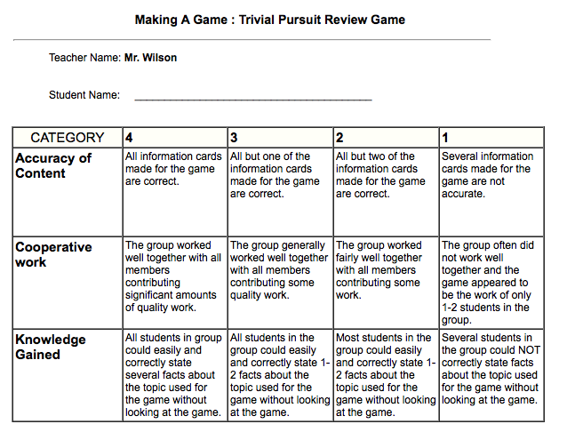

Canadian History 11: Trivial Pursuit Review Project

Canadian History 11
Mr. Wilson
mrwilson@nspes.ca

This assignment will have you working in groups (six total) to create review questions for the main time periods we have covered in class this year. You will be randomly placed in one of these six groups and you will have to create fifteen questions as a group for the topic you are assigned. The questions will be placed into a PDF form I will provide and we will play the game in the end as a form of review.

Process

1) To start, Mr. Wilson will create six random groups using the TeamShake app.

2) The groups will be as follows:

Blue Group: Pre-Contact History
Pink Group: Post Contact History
Yellow Group: World War One History
Brown Group: World War Two History
Green Group: Post World War Two History
Orange Group: Random Canadian History Facts

3) Once in your group, you will use your notes, online information, textbook, and other information to create 15 questions on the topic you are given.

4) As a group, you will edit your questions and answers to make sure they are accurate, free from spelling errors, and to ensure all members are happy with the questions you have created.

5) Once your group is happy with your questions, you will place them in the master PDF form that I will give each group. Make sure they are entered properly.

6) Once all the questions from each group is submitted, Mr. Wilson will print off all the cards.

7) Next, we will play the game. We will take out time to make sure all questions are asked and each person gets a chance to play. We will repeat as necessary.

8) Check this list to make sure you have included all the elements:

Rubric

