Canadian History 11: Residential School Photo-essay Project

Canadian History 11
Mr. Wilson
mrwilson@nspes.ca

Driving Question: How do images portray the dark legacy of Residential Schools in First Nations and Canadian History.

Outcomes Covered:
- GL2 analyse the effects of contact and subsequent colonization
- S3 analyse the struggles of First Nations to re-establish sovereignty

Expected Length of Lesson:
- Four 50-minute classes.

Resources Needed for Lesson:
- Teacher computer with access to the Internet.
- LCD projector to connect to teacher computer.
- Computer lab access with computers for each student (room 205)
- Assignment handout.

Purpose of the Lesson:
- Students will see the benefit photos to tell about an event in history.
- Students learn to collaborate with their peers.
- Students will possibly learn to use a presentation format they haven’t used before.
- Students will learn to conduct research.
- Students will learn to make a bibliography.
- Students will learn the fundamentals of photo-essay projects

Rubric
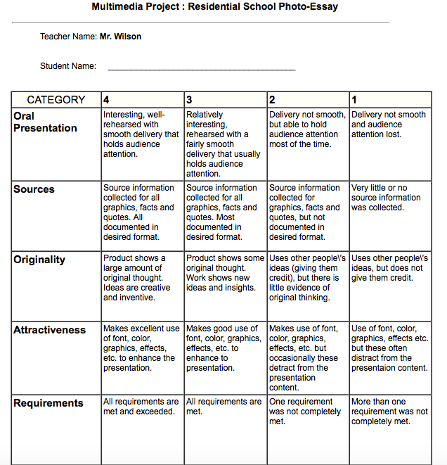

Lesson Process

- First class: 1) The teacher will hand out the assignment sheet and go over the expectations for the assignment. 2) The students will review the sheets and ask any questions of the teacher before starting. 3) Students will divide themselves into groups of two. 4) Students will decide on what format they would like their presentation to be in (Powerpoint, Keynote, Prezzi, iMovie, et… 5) Students will begin their primary research. 6) Before the end of class, the teacher will bring the class back together to remind them that next class will be devoted to conducting research.

- Second class: 1)The teacher will review what was accomplished yesterday, and reinforce the importance of focusing on the presentation. 2) Groups will get together to get the photos and information they need for the presentation. 3) Remind the students to document their photos and information in a bibliography. 4) Students will start making their presentations. 5) Bring the class back together to enforce the importance of finishing their project tomorrow.

- Third class: 1) Meet with the group to outline the goal of finishing the project today. 2) Allow the groups to make their project. 3) The teacher will mover around to the groups to answer questions and guide the groups 4) Meet before the end of class to remind groups that the presentations will be tomorrow.

- Fourth class: Today will be focused entirely on presentations. Have students take pride in their finished products.

Residential School Photo-Essay Project
Canadian History 11
Mr. Wilson
mrwilson@nspes.ca

For this project, you will be creating a photo-essay on Residential Schools in Canada. This project can be displayed in any manner you wish (Powerpoint, iMovie, Keynote, Prezzi, etc…) and can be done in groups of two. At the end, you will present your final product to the class.
The first thing you might ask is what is a photo-essay? A photo-essay is a series of high quality photos that are powerful images that can in themselves tell a story. Each photo will be accompanied with a brief write-up below helping to explain the photo.
For this assignment, you will be focusing on Residential Schools in particular. This photo-essay will use images to explain the dark legacy of Residential Schools in Canadian History. Below, I will provide you with a rough guideline that you could follow to make sure you have everything you need.

The Process

- Pick a group member you work well with.
- In your group, decide on what presentation tool you will use. This is open to you. Examples could be Prezzi, PowerPoint, Keynote, iMovie, etc… Don’t be afraid to try new programs.
- Begin looking for the photos that will fit into your presentation. These photos should be high quality and fitting for the project.
- You should add a brief write-up below each photo. This will provide more detail for the audience.
- Appropriate music should be added in the background. This music should not be distracting or overwhelming for the audience. The music should also be free use music.
Try these sites:
-Ben Sound (my favorite): http://www.bensound.com
-Creative Commons: http://creativecommons.org/legalmusicforvideos
-Jamendo: https://www.jamendo.com/en/welcome
- You will need to provide the teacher with a bibliography of the photos and information you used.
- The final presentation should have a minimum of 15 slides.
- At the end, you will present your final project to the class.

The Photos
Here are some guidelines to photos and topics you could include:
- The church officials involved.
- The government officials involved.
- The buildings themselves (images inside and out)
- Students being rounded up.
- Students being assimilated physically (cut hair, European clothing, etc..)
- Students in class.
- Religious conformity (students praying, alter boys, etc…)
- Punishment (whipping, strapping, isolation)
- Work in the schools (farms, lumbering, yard maintenance, cooking, cleaning, etc..)
- Maps of the Residential Schools in Canada
- The closing of the schools
- The aftermath (Truth and Reconciliation Commission, public apologies, Harper’s apology, etc..)
- And so on……..I will help you on individual basis.
How you will be marked:

