Canadian History 11: First Nations Creation Myths

Canadian History 11
Mr. Wilson
mrwilson@nspes.ca

Driving Question: What are the traditional beliefs of First Nations from around North America on the creation of their people? How do these creation myths differ?

Outcomes Covered:
- GLI investigate and assess various traditional and emerging theories regarding the peopling of the Americas

Expected Length of Lesson:
- Two 50-minute classes.

Resources Needed for Lesson:
- Teacher computer with access to the Internet.
- LCD projector to connect to teacher computer.
- Computer lab access with computers for each student (room 205)
- Assignment handout.
- Watch the following creation myth videos to get ideas of some of these stories
Iroquois Story: https://www.youtube.com/watch?v=v4UlT4j82SU
Ojibway Story: https://www.youtube.com/watch?v=Etn92Ms8plo
Haida Story: https://www.youtube.com/watch?v=yhXZv1tJ2Ak
Mi’kmaq Story: https://www.youtube.com/watch?v=rQvup95nhvk
- Visions textbook (page 13)
- Colouring pencils or markers
- 8x11 paper (for good copy)

Purpose of the Lesson:
- Students will understand the traditional creation beliefs of First Nations around North America.
- Students will have a better understanding of how the creation beliefs of Europeans and First Nations differ greatly.
- Students will create an illustration and write-up for a group of their choice.
- Students will learn how to research the group of their choice.
- Students will have to decide on what scene from the myth they would like to focus on.

Rubric

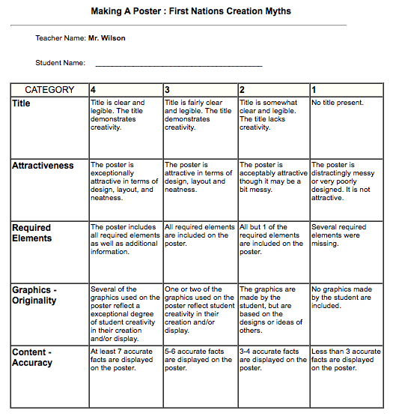

Lesson Process

- First class: 1) The teacher will hand out the assignment sheet and go over the expectations for the assignment. 2) The students will review the sheets and ask any questions of the teacher before starting. 3) Students will watch the following videos on some example creation myths:
Iroquois Story: https://www.youtube.com/watch?v=v4UlT4j82SU
Ojibway Story: https://www.youtube.com/watch?v=Etn92Ms8plo
Haida Story: https://www.youtube.com/watch?v=yhXZv1tJ2Ak
Mi’kmaq Story: https://www.youtube.com/watch?v=rQvup95nhvk
4) Students will review other creation myths from their textbook (page 13) to get an idea of some traditional First Nations beliefs. 5) Students will pick what group and myth they would like to illustrate and write about tomorrow.
6) The teacher will wrap up the class by explaining that tomorrow will be used to create their poster and writeup.

- Second class: 1) the teacher will review what was accomplished yesterday, and reinforce the importance of focusing on the illustration and write-up.2) Students will use their devices of lab computers to research their myth.3) Students will illustrate their myth on a piece of 8x11 paper.4) The poster must have a title, colour, and their own illistrations.5) Students will place their write-up with their illustration. 6) The teacher will close the lesson by explaining the plan for tomorrow.

First Nations: Traditional Creation Myths Poster

Canadian History 11
Mr. Wilson
mrwilson@nspes.ca

Now that you have looked at creation myths of aboriginal groups, you will now research and illiterate a myth/story from a group of your choice (must be from North America). Read the example of a creation myth on pages 13 and 14 to get ideas. Your final myth must have a write-up summarizing the myth, your drawing interpretation of the myth you choose, and colour. Before you start, watch the following videos on YouTube to get ideas of these myths:

Iroquois Story: https://www.youtube.com/watch?v=v4UlT4j82SU
Ojibway Story: https://www.youtube.com/watch?v=Etn92Ms8plo
Haida Story: https://www.youtube.com/watch?v=yhXZv1tJ2Ak
Mi’kmaq Story: https://www.youtube.com/watch?v=rQvup95nhvk

Your myth must include:

- A name of your native group as a title
- It must be at least two paragraphs long.
- It must contain information about who created your people or how they were created.
- You must accompany your myth with a colored picture (your drawing…not copied) that shows a scene from your myth (like on page 13 of the textbook).
- Be as creative as possible…use your imagination.

Example myths to research: (This is just a small list. Pick any others of your choice (please clear with me first).

-Mi’kmaq -Chelan
-Cherokee -Lakota
-Creek -Navajo
-Hopi -Potawatomi
-Choctaw
-Haida
-Dine
-Zuni
-Kuterastan
-Seminole
-Anishinaabeg
-Apache

How you will be marked:

