Canadian History 11: Canada during the Cold War Timeline Project

Canadian History 11
Mr. Wilson
mrwilson@nspes.ca

Driving Question: What was Canada’s role in the post World War Two world as the Cold War erupted between the east and west?

Outcomes Covered:
- GL6 analyze the evolution of Canada’s roles in the late twentieth century.
Expected Length of Lesson:
- Three 50 minute classes
Resources Needed for Lesson:
- Teacher computer with access to the Internet.
- LCD projector to connect to teacher computer.
- Computer lab access with computers for each student.
- Assignment handout.
- Access to copies of the app “Timeline 3D” https://www.beedocs.com/timeline3D/mac/
- Class set of IPads with the Timeline 3D app
- Access to the Air server for presentations
- TimeLine 3D tutorial video: https://www.youtube.com/watch?v=V7HN535y1pU
- TimeLine 3D example video:
https://www.youtube.com/watch?v=BXOupSWb10Q
- The Teamshake app to randomize group presentation order.

Purpose of the Lesson:
- Students will learn to work in groups to conduct research and create a final timeline project.
- Students will get an idea of how the world went from World War Two to the Cold War.
- Students will understand the events of the Cold War in the post-war world.
- Students will understand Canada’s role in the Cold War as tensions between the Soviet Union and the United States of America.
- Students will learn how to make a chronological timeline.

Lesson Process

- First class: 1) The teacher will hand out the assignment sheet and go over the expectations for the assignment. 2) The students will review the sheets and ask any questions of the teacher before starting. 3) Students will pick their partner for this assignment. This can be done on their own. Encourage them to pick someone they know they can work with and will share the work. 4) Have students watch the two example videos explaining Timeline 3D: https://www.youtube.com/watch?v=V7HN535y1pU
https://www.youtube.com/watch?v=BXOupSWb10Q
4) Allow students time to play with the Timeline 3d app on the classroom IPads or their own devices if they have the app.
5) In groups, students will begin to do exploratory research on the Cold War event of their choice.6) By the end of the class, the groups will decide on what topic they will do their project on.
7) The teacher will wrap up the class by explaining that tomorrow will be used to create their final timeline presentation using the Timeline 3D app on the class Ipads.

- Second class: 1) the teacher will review what was accomplished yesterday, and reinforce the importance of focusing creating and finishing their timeline in today’s class. 2) Students will get in their groups and begin using their research from yesterday to compile their timeline using the Timeline 3D app 3) Students will create their timeline. This timeline must have a minimum of 15 chronological dates, have short descriptions for each date, and media to accompany at least 8 of the dates (video, images, etc.…4) The teacher will close the lesson by reminding groups that their projects are due tomorrow and will be presented to the class using the Air Sever.

- Third class: 1) the teacher will use the TeamShake app to randomly pick the order of groups presenting. 2) Each group will present their timeline using the class Air server. 3) the teacher will end the lesson by providing feedback and fielding any questions.

Possible Topic

Below is a short list of events students can decide to research for their timelines. Students have some background from class in these events but will need to do further research to complete the timeline.

- Canada during the Korean War
- The Creation of NATO and the Warsaw Treaty Organization
- The Berlin Airlift
- Canada and NORAD (North American Aerospace Defense Command)
- Canadian Peacekeeping Missions associated with the Cold War
- Congo
- Cypus
- The Sinai
- The Golan Heights
- Lebanon
- Nambia
- Canada’s role in the Vietnam War
- Canada’s role in the Suez Crisis
- The creation of (UNEF) United Nations Emergency Force
- Canadian military presence in Europe
- Any other topic that you discover in your research. Cleared with the teacher first.

Rubric:

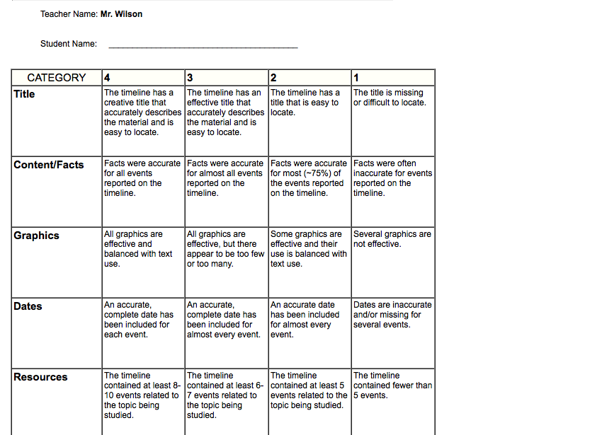

Canada in the Cold War: Timeline Assignment

Canadian History 11
Mr. Wilson
mrwilson@nspes.ca

This assignment will delve into the events that led the world into the Cold War. For this assignment, you will be conducting some research on a Cold War event, and creating a visual timeline using the Timeline 3D app

Process

1) To start, decide on your partner that you would like to work with. Please pick someone you can work well with and who will share the workload with you.

2) Watch the two videos on the Timeline 3D app that will explain how to make a timeline using this program, and what a finished presentation could look like.

3) Take a classroom Ipad that already has the app. You can download it on your own device from: https://www.beedocs.com/timeline3D/mac/

4) As a group, review the topics listed below. It is recommended that you collaborate with your other group member to decide the topic you wish to cover. Use your devices to explore a few.

Topic Examples:

- Canada during the Korean War
- The Creation of NATO and the Warsaw Treaty Organization
- The Berlin Airlift
- Canada and NORAD (North American Aerospace Defense Command)
- Canadian Peacekeeping Missions associated with the Cold War
- Congo
- Cypus
- The Sinai
- The Golan Heights
- Lebanon
- Nambia
- Canada’s role in the Vietnam War
- Canada’s role in the Suez Crisis
- The creation of (UNEF) United Nations Emergency Force
- Canadian military presence in Europe
- Any other topic that you discover in your research. Clear it with me first.

5) Once your topic is picked, begin research of that event. Jot down notes, key facts, and most importantly dates.
6) On scrap paper, make a rough copy of how your timeline may look like. You will need to have 15 chronological dates and at least 8 forms of visuals (video and photos) that are embedded in your final timeline.

7) Begin setting up your good copy on Timeline 3D. Be sure to keep the communication open with your partner and make sure each person has a role to play. For example, one may want to fill all information into the timeline while the other validates facts and checks for spelling errors.

8) Check this list to make sure you have included all the elements:

- A title that represents the content of the material being presented.
- 15 events/dates representing the topic you have chosen.
- Photos and video that represent the events you have included in your timeline (at least 8)
- Music clip that plays while your presentation is being shown. This music should be appropriate and fitting (instrumental is ideal).
- A list of references used in the making of the timeline.

9) Present to the class. Be proud of your final product and enjoy showing it to others

Rubric on next page:

