Canadian History 11: Acadian History Blog Assignment

Canadian History 11
Mr. Wilson
mrwilson@nspes.ca

Outcomes Covered:
- J2 demonstrate an understanding of the relationship between land and culture and analyze the effects of displacement
- J4 demonstrate an understanding of how the lack of political and economic power has led to inequities and analyze the responses to these inequities
- J5 analyze the evolution of the struggle to achieve rights and freedoms

Expected Length of Lesson:
- Three 50 minute classes (First class: review online blog , create groups, answer questions. Second class: Character creation and research. Third class: Create the blog. Fourth class: Present to the class.).

Resources Needed for Lesson:
- Teacher computer with access to the Internet.
- LCD projector to connect to teacher computer.
- Computer lab access with computers for each student.
- Assignment handout.
- Access to either the Twitter account or blog of “Walter Carter: World War One Soldier’s Tale”. (follow @WW1SoldiersTale on Twitter).
http://www.ww1soldierstale.co.uk
- “Make My Groups” randomizer app to make team lists.
https://itunes.apple.com/us/app/make-my-groups-flexible-team/id491231909?mt=8
- Teacher IPad with “Make My Groups” app.

Purpose of the Lesson:
- Students are to get a better understanding what the deportation of the Acadians had on these people and their culture.
- Students will place themselves in the shoes of these people and write from the perspective of these people.
- Students will need to show historical accuracy of the facts and events in their blog write-up.
- Students will need to work together with other group members to create, analyze, question, and present their project.
- The final product will be presented to the class before it is handed in for marking.
- The students will hopefully learn from the other groups during the presentations. They will see differing perspectives and stories from each group that will all be tied to the deportation.

Lesson Process

Day 1
- Review and introduce the upcoming assignment to the class.
- Randomize the class into groups of three. This class has 27 students so there should be ten groups total. Use the “Make My Groups” app to do this…this is on my teacher IPad in my filing cabinet (I have left the keys).
- Hand out assignment sheet and go over it with the class.
Show how to navigate to the blog: http://www.ww1soldierstale.co.uk and Twitter account (@WW1SoldiersTale) to the class. This is just to show them how a blog can look like.
- The students will meet in their groups and look at the Walter Carter blog together
- Allow groups to answer the questions in part 2 of the assignment together. Their answers must be typed and passed in with the final assignment.

Day 2
- The groups will create three characters for their blog. Each member of the group will assume the role of one character.
Once the characters are created, the group must create a bio for each person. This will include names, birth dates, hobbies, physical descriptions, and so on. These will be included in the final product. Examples of profiles are on the Walter Carter blog (http://www.ww1soldierstale.co.uk)
- Groups are to research the time period around the deportation (which took place in 1755. They must have ten entries so should pick a time when plenty is happening. This could be the events leading up to the deportation.

Day 3
- Students will now write their blog entries. They must keep in mind to immerse themselves in their character, the time period, and the key historical events around the time of focus the group chooses.
- Their entries should be typed in a program of their choice for presentation and submission. This could be Weebly (does not need to be publically published), Word, Publisher, Keynote, IMovie, etc.…they group can pick whichever one they desire.

Day 4
- The last day, groups will present their entries to the class. They will introduce their characters and then read their entries. Each member of the group is responsible for one character.
- Finish the class by reviewing what was learned and giving your general impression of the finished product.

Rubric on the next page

Rubric
Category | 4 | 3 | 2 | 1
Character Development | The blog contains at least three well-developed characters who are historically believable. | The blog contains at least three well-developed characters that are often historically accurate. | The blog does not contain three characters but the ones that are present are historically accurate. | The blog does not have the required amount of characters and they are not historically accurate.
Historical Accuracy | The blog is completely historically accurate and has great detail throughout | The blog is generally historically accurate throughout. | The blog has historical accuracies throughout. | The blog has no evidence of historical accuracy.
Post Quality and Length | Posts are well written, and are characterized by elements of a strong writing style.  Posts are the appropriate length | Posts show above average writing style  The posts are the appropriate length. | Posts show a below average, overly casual writing with a lack of attention to style. Posts are not the appropriate length. | Posts are of very poor quality. The writing is hard to follow and the posts are too short.
Final Blog Presentation | The blog is attractive and well designed. It is evident great care has been put into the final product. | The blog is fairly attractive and well designed. It is evident that time was taken to make the product appealing. | The blog lacks visual appeal and looks rushed in places. | The blog is not finished and is not of presentable quality.
Teamwork | The members of the group worked well throughout and shared the work evenly. | The members worked well together but the work was not shared evenly at times. | The members did not cooperate from time to time and work was not shared evenly throughout. | The members were often at odds with each other and work was not shared evenly. They lacked cooperation.

Acadian Deportation Blog Assignment

Canadian History 11
Mr. Wilson
mrwilson@nspes.ca

This assignment will help us delve deeper into the lives of the Acadian people of the Maritimes during the mid to late 1700’s. During this time, the Acadian people found themselves torn between their home nation of France and the conquering forces of Britain. For years, the British monarchy has allowed the Acadians to survive on British occupied land as long as they followed British rules. During the mid 1700’s these rules began to become more restrictive and conflict would eventually follow from 1755-1763.
This assignment will get you to create a blog as if you were writing as members of the Acadian community. You will write historically accurate accounts from made up characters. Put yourselves in the shoes of the people living in the mid 1700’s

Part 1

To start, examine either the blog or Twitter feed titled “Walter Carter: World War One Soldier’s Tale”. Click to access the blog or follow @WW1SoldiersTale. Both ways will provide you with the same information; you can choose which method suits you best.

Here is what the Twitter profile should look like:

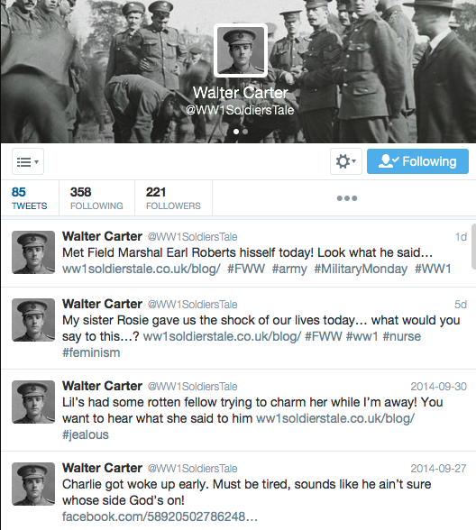

Here is what the blog looks like:

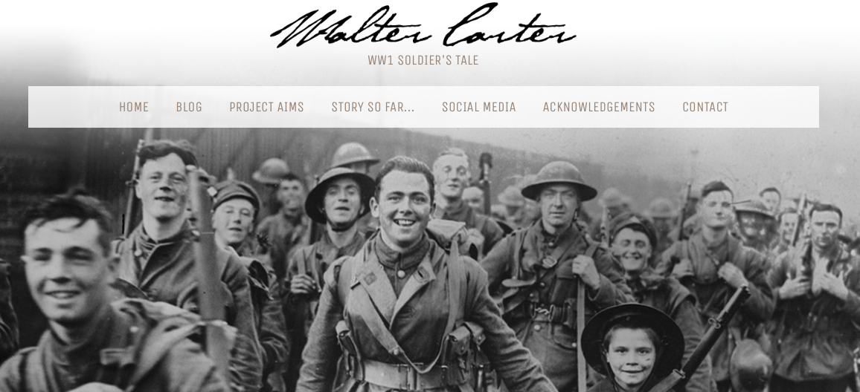

Take some time to examine the characters, story so far and structure of the blog. As you will see, the author has created multiple characters that write during the process. The Blog and Twitter will follow these characters for 100 days during the war and it gives a perspective of what was happening during each day of the war. If a big battle happened during that day, the characters often talk about it. It is a great way to see what it would have been like.

Part 2:

This assignment will be done in randomly picked groups of three. Once you are given your group, meet and discuss your opinions of the blog or Twitter feed, and what it must have been like to live at this time. Answer the following:

- What does your group think it would be like for the everyday soldier in World War One? What are the fears, emotions, and thoughts they may be dealing with?
- What would it be like for the family back home waiting on their soldier? How would you feel if you were a father, mother, sibling, wife, or friend?
- How important would letters and communication have been at this time? What do you think individuals would gain from these letters?
Part 3:

In your group, create a minimum of three characters you will be following in your blog. These names should be fictional. You are then asked to type up a profile with each person. The profiles must be similar to what people would be like in 1700 eastern Canada. You might want to look up what people did for entertainment or what jobs they may have done. Make up their story; give them likes, dislikes, hobbies, and quirks. Here are some requirements:

- One character must be the father or mother of the household.
- One character must be a young child.
- All characters must have a character bio.
- The character bio must have: life stats (birth date, marital status, age, etc..)
- The bio must have a picture (drawn or real), hobbies, and hometown.
- All characters must be historically accurate (example: a women working as a farmer in 1700 would not mention machinery like tractors or the character cannot mention things that have not happened historically yet).
- All characters must be Canadian or present a Canadian perspective (this is Canadian History 11 after all ).

Part 4:

- You are to type a series of communications (at least 10 entries…entries must be 1 paragraph long). By the end of these entries, all of your characters must have spoken from their perspective.
- You should cover a short period of history. Are you going to write from the beginning of tensions between the Acadians and the British? How about after 1755 when the deportation was underway? It is up to you the short period you wish to focus on. Remember that dates need to match facts. You will probably need to conduct research as you go.
- This blog can be typed in Word, on an unpublished website created on Weebly, journal style in Publisher, or any other method you choose.
- The beginning of the blog should start with the profiles you created and then be followed with your minimum ten entries that include historical facts and dates (see the blog and Twitter accounts in Part 1).

Part 5:
We will take one class to present your blog to the class. Each group member is to take on one of the characters that they will read during the presentation. For example: Bill will be the father and will only read the father’s entries, Bob will be the man’s wife and read her parts only. Your final blog, character profiles, and questions from part 2 will be handed in for marking.

How you will be marked is on the next page

Category | 4 | 3 | 2 | 1
Character Development | The blog contains at least three well-developed characters who are historically believable. | The blog contains at least three well-developed characters that are often historically accurate. | The blog does not contain three characters but the ones that are present are historically accurate. | The blog does not have the required amount of characters and they are not historically accurate.
Historical Accuracy | The blog is completely historically accurate and has great detail throughout | The blog is generally historically accurate throughout. | The blog has historical accuracies throughout. | The blog has no evidence of historical accuracy.
Post Quality and Length | Posts are well written, and are characterized by elements of a strong writing style.  Posts are the appropriate length | Posts show above average writing style  The posts are the appropriate length. | Posts show a below average, overly casual writing with a lack of attention to style. Posts are not the appropriate length. | Posts are of very poor quality. The writing is hard to follow and the posts are too short.
Final Blog Presentation | The blog is attractive and well designed. It is evident great care has been put into the final product. | The blog is fairly attractive and well designed. It is evident that time was taken to make the product appealing. | The blog lacks visual appeal and looks rushed in places. | The blog is not finished and is not of presentable quality.
Teamwork | The members of the group worked well throughout and shared the work evenly. | The members worked well together but the work was not shared evenly at times. | The members did not cooperate from time to time and work was not shared evenly throughout. | The members were often at odds with each other and work was not shared evenly. They lacked cooperation.

