Canadian History 11: World War One Attestation Paper Project

Canadian History 11
Mr. Wilson
mrwilson@nspes.ca
Driving Question:
- Who were the solider who were joining the Canadian Overseas Expeditionary Forces? Where did they come from, what were their backgrounds? What were the men like who we asked to fight for Canada?

Outcomes Covered:
- GL4 analyze the role played by WWI in shaping Canada’s identity.

Expected Length of Lesson:
- Two 50 minute classes.

Resources Needed for Lesson:
- Teacher computer with access to the Internet.
- LCD projector to connect to teacher computer.
- Computer lab access with computers for each student.
- Assignment handout

Purpose of the Lesson:
- We have been examining the role of Canada during World War One (1914-1918). Students have been given previous lessons on the cause of the war, Canada’s relationship with Britain, how this war is unique in terms of new technology and level of destruction. Students have a good grasp of the overall history of the conflict before this lesson.
- For this lesson, students are going to examine the human side of this conflict. We have talked previously about the human numbers Canada contributes (just over 600,000 men enlist and around 60,000 soldiers were killed). This lesson will show that these were not just numbers in their notes but actual people.
- They will examine an online database containing Attestation Papers (forms signed by all soldiers joining the Canadian Overseas Expeditionary Force), burial information (Commonwealth War Graves Commission) and Circumstances of Death Records (Library and Archives of Canada).
- I will provide five soldier names we have examines previously in class (John McCrae, Alexis Helmer, William Bishop (Billy), Agar Adamson, and Roy Brown. They will look up the forms of these men and answer some detail about them
- After they complete this section, they will examine five people of their choice. I have asked them to jot down possible family members or community members to look up. I usually have ¼ of my average sized classes find personal family connections, which makes this unit more personal for those students.
- The last piece of the assignment will have student immerse themselves into the lives of soldiers and families of the time. They will have to write a short letter from this perspective.

Lesson Process

Day 1:
- Review slideshows that gives overview of World War One (if needed by the substitute).
- Hand out assignment sheet and go over it with the class.
- Show how to navigate to the website and how to search the database on the LCD so all students see what to do.
- Allow students to get on the computers and make sure everyone can access the website.
- Allow students to find the soldiers I have provided to them. Give pointers on how to read and decipher cursive writing as needed.
- Five minutes before the end of class, pull the group together to discuss and evaluate how students are adapting to the database.
Day 2:
1) Start the class by reviewing how students managed with the database on day one. Field any problems or concerns.
2)Allow students to look up their own five names once they have looked up the provided list provided to them.
3)Once all soldiers and information have been found, introduce the website for the Commonwealth War Graves Commission and Circumstances of Death Records. Have them look up casualties from the list I provided (both John McCrae and Alexis Helmer die during the war).
4) Once they get the hand of these two new databases, allow students to explore their own family records (if any) or simply explore names of their choice.
5)Once all students have completed the assignment, have them present their findings of their individual names to the class. The written findings can be handed in the class inbox for review by me.
6)Talk about what the students have discovered in this assignment. Hopefully most will now understand that the causalities were not just numbers but people with families and lives before the outbreak of war.
7)Finish with a personalized letter that will ask students to imagine what life would be like as a soldier or as a family member of a soldier at this time.

Today’s Lesson:

Today, students will learn about the personal side of World War One on Canadian soldiers and their families. They will be using an online database on the Library and Archives webpage to research famous soldiers and hopefully family relatives or community members.
We have been going over World War One for the past week and the students have a good understanding of the causes of the war, who was involved, and what the fighting was like. This assignment will put names and faces to the statistics we have looked at up to this point.

Outcomes Covered:
- GL3 demonstrate an understanding that Canada’s development was influenced by evolving relationships with France, Britain, and the USA.
- GL4 analyze the role played by WWI in shaping Canada’s identity.
- GL6 analyze the evolution of Canada’s roles in the late twentieth century.

What You Will Need:

- Copy of the assignment sheet. I have made copies and they are on my desk.
- Computers with Internet access. I have booked the computer lab (Room 205) for this period. There are enough working computers for all students but they can use their own devices if they wish).
- Access to the Library and Archives of Canada website: Link
- Access to the Commonwealth War Graves Commission website: Link
- Access to the Circumstances of Death Registry on the Library and Archives of Canada website: Link
- Copies of World War One PowerPoint presentation we have examined in the past few classes. These are to familiarize yourself with the material if need be.

Process:

- Review slideshows that gives overview of World War One before class to familiarize yourself with the background material (if needed). These can be found on my school computer at the back of the room.
- Hand out assignment sheet and go over it with the class.
- Show how to navigate to the website and how to search the database on the LCD so all students see what to do.
- Allow students to get on the computers and make sure everyone can access the website.
- Allow students to find the soldiers I have provided to them. Give pointers on how to read and decipher cursive writing as needed.
- Allow students to look up their own five names once they have looked up the provided list provided to them.
- Once all soldiers and information have been found, introduce the website for the Commonwealth War Graves Commission and Circumstances of Death Records. Have them look up casualties from the list I provided (both John McCrae and Alexis Helmer die during the war).
- Once they get the hand of these two new databases, allow students to explore their own family records (if any) or simply explore names of their choice.
- Once all students have completed the assignment, have them present their findings of their individual names to the class. The written findings can be handed in the class inbox for review by me.
- Talk about what the students have discovered in this assignment. Hopefully most will now understand that the causalities were not just numbers but people with families and lives before the outbreak of war.
- The final step is to have students complete the letter writing assignment at the end of the assignment sheet. This will be continued when I return if there is not enough class time to finish.

Online Database Assignment: World War One Attestation Papers

Canadian History 11
Mr. Wilson
mrwilson@nspes.ca

As we have discussed in this unit, everyday Canadians played a major role in World War One. When the troops signed up, they would be made to enter their information on Attestation Papers. With the emergence of new technology, these papers have been scanned and placed on an online database for public use. To start off, access this website:
http://www.collectionscanada.gc.ca/databases/cef/index-e.html
**If this site does not work, simply type “World War One Attestation Papers” in Google and click on the Collections Canada link.

Part 1: Review the following videos:

Video #1: How to use the attestation paper database from the Canadian Library and Archives website:
https://www.youtube.com/watch?v=EuApE39Q9K0

Video #2: This video will show you how to use the circumstances of death registry from the archives website. It is a little cumbersome so hopefully this video will help.
https://www.youtube.com/watch?v=qQLK2IbaVl8

Video #3: This video will show you how to use the Commonwealth War Grave Commission. This database has files for all servicemen and women who have died while serving the Commonwealth in World War One and Two.
https://www.youtube.com/watch?v=WbPXCLdXIIk

Part 2

Once on this site, click on the “search” button on the left side of the page. Once in the search screen you can now search for the information you desire. It should look like this:

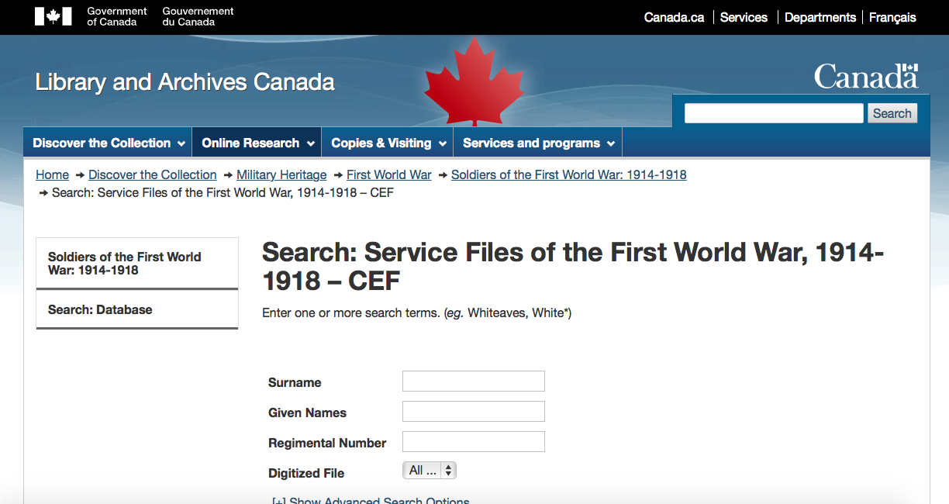

Once you have entered the database, I would like you to start of by finding the attestation papers of the following famous Canadians we have already examined in class (you may need to look information on these men to narrow your search (ex. Date of birth, hometown, etc…):

- John McCrae-Author of “In Flanders Fields”.
- William Avery Bishop (Billy)- WW1 fighter ace.
- Alexis Helmer (friend of McCrae’s who’s death inspired “In Flanders Fields”).
- Agar Adamson- Featured in “For King and Empire” series.
- Roy Arthur Brown- WW1 ace credited with shooting down “The Red Baron”

Part 3:

Once you have found the papers on these men, answer the following for each:

- What is the full name of the man?
- Where and when was this man born?
- Who is listed as his next of kin?
- What is his trade or calling?
- Where they ever part of the active militia? If so which group?
- Any other interesting information (height, scars, eye/hair color etc….)

Part 4:

Now I would like you to do a search of either a family name or a name from this area. Pick five names from your family and Nova Scotia (preferably the South Shore Area) and answer the above information you completed for the previous five soldiers. Be prepared to discuss your findings in the next class.

Part 5:

When you are finished, go to the Commonwealth War Graves Commission (www.cwgc.org) and explore some of your own family names (hopefully you will not find any).
If you have found some names of interest on the Commonwealth War Graves Commission website, look up the Circumstances of Death records on the Library and Archives
(http://www.bac-lac.gc.ca/eng/discover/mass-digitized-archives/circumstances-death-registers/Pages/circumstances-death-registers.aspx ) to possibly learn more on their death.

Part 6:

Reflection Letter:
Please take time at the end of this assignment and reflect on what you have uncovered. Place yourselves in the shoes of these young men and women who were signing these attestation papers to go overseas. What would they be feeling? How would their loved ones feel?
I would like you to create a short (two paragraph minimum) letter from the perspective of a solider you researched or a loved one of that soldier talking about what life would have been like at the time of signing up or once the war has started. Use your knowledge from the entire unit (class notes, handouts, videos, attestation paper assignment, etc..) to formulate your thoughts.
You should include:

- Opening greeting (Dear so and so)
- Date (think about dates we have covered).
- Thoughts on the war or participation (personal feelings, fears, excitement, nationalistic pride, anger, etc..) from the perspective of someone who lived through this terrible historical event.
- A closing (Sincerely, Love, Ever Thine (remember Agar Adamson’s letters to his wife we examined earlier in the unit), etc.).

Remember to immerse yourself in the feelings of the time. Go back in time. I would like this letter to be hand written (remember they didn’t have readily access to typewriters at the front). You will share this letter with the class next day.

Due Date: To be Announced.

Grading Rubric

 | 4 | 3 | 2 | 1
Provided Soldiers | The soldier’s details were all included with accuracy and detail. Extra information included. | The soldier’s details were all included with accuracy and detail. Extra information was not included. | The soldier’s details were all included but there were inaccuracies in the details. Extra information was not included. | The soldier’s details were not complete and contained inaccuracies.
Personal Soldiers | The soldier’s details were all included with accuracy and detail. Extra information included. | The soldier’s details were all included with accuracy and detail. Extra information was not included. | The soldier’s details were all included but there were inaccuracies in the details. Extra information was not included. | The soldier’s details were not complete and contained inaccuracies.
Reflection Letter | The letter was written in proper format and contained historical information that was accurate.  The letter was the proper length. | The letter was written in proper format and contained historical information that was accurate.  The letter was not proper length. | The letter was written in proper format but contained historical inaccuracies. The letter was not proper length. | The letter was not written in proper format and contained historical inaccuracies. The letter was not proper length.

